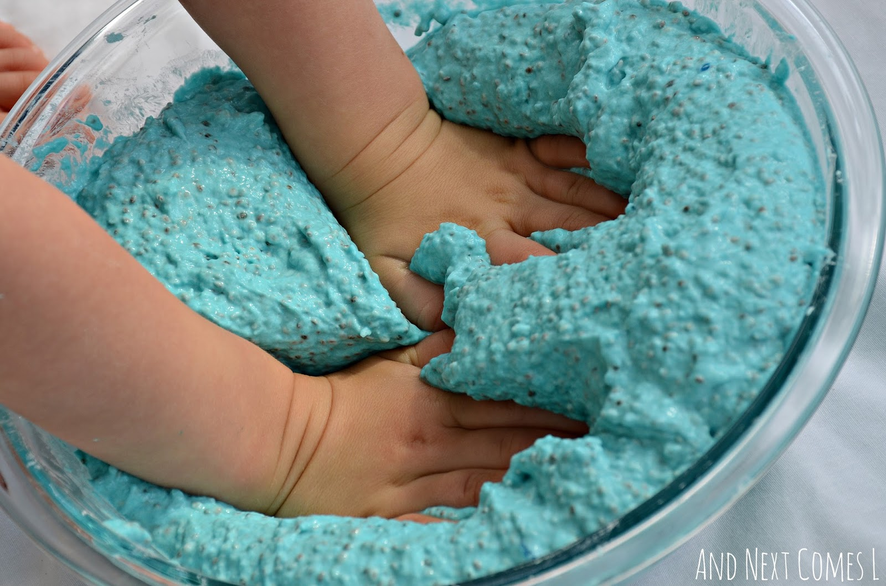

Parenting is hard. It may very well be the hardest job in the world, but without legally enforced breaks or work conditions. Basically these tiny people are our bosses, HR, PR and line managers all rolled into adorably squeaky packages.

My aim here is to acknowledge the fact we *do* and *experience* parenting differently to PNT (Predominant Neurotypes). There is no worth in comparing, or using the words ‘better’ or ‘worse’ here but it helps to acknowledge that our autistic brains offer a different prism through which we see the world. Now that prism is covered in sticky handprints and the toddler is threatening the dog with it.

Okay, I'm bored of your metaphors get on with it.

To put it simply, some people are surprised adult autistic people exist. They're quite taken aback that we manage to procreate and build families, too. But they're the minority by far. The vast majority of other parents are so tired they don't have the energy to even think about it. It's quite freeing! This a great time for those who enjoy ‘tell it like it is’ conversations and friendships where gaps in communication are forgiven without questioning.

Sources of stress

#1) The Tiny Person.

The baby itself is a ball of wonderful, but often overwhelming, sensory stimulation. They are always in earshot, loudly protesting or demanding. They want to be attached to us at all times, this is even more intense for breastfeeding mothers. The smells range from putrid to heavenly and you can't take your eyes off them for long. Every sense is activated 24/7 and it is exhausting.

#2) Other people.

Before baby even arrived, knowing your family is growing gives folk an open invite to offer advice, ask questions or judge. This doesn't change and it’s hard to resist without hurting feelings. Kids are magnets for people who want to insert themselves into your day.

Minimising Burnout.

A practical, non-judgmental collection of tips for autistic parents by autistic parents.



**Use your scripting.**

There are many occasions that scripting (preparing for conversations in advance) is useful. It’s great to have pre-prepared phrases for situations where you feel uncomfortable with baby.

If your Health Visitor doesn't know how to speak to autistic adults well, have a book title or reference ready. If someone offers unsolicited advice or touches your baby without asking, have a neutralising phrase prepped.

When people see someone visibly trying to be left alone they'll pick up on that half the time and leave you alone. When you have a child with you, be they a shiny newborn or a tantruming toddler, all people see is the child, not you. They'll go out of their way to strike up conversations with you, touch your child's face, comment on their appearance and behaviour.

This is a horrible invasion of our space to us and utterly normal and polite to them. Use a scripted phrase if possible, try to understand their intentions. If you can't, just walk away. Chances are you'll never see them again anyway!

Strategies for Minimising Burnout

Accept help whenever you are offered.

Now is not the time for guilt or judging yourself. Think of it as the rule on aeroplane safety; you have to put your oxygen mask on before you can save others.

**Fight sensory with sensory**

Sensory play will benefit you and baby. Stick to comforts you like, browse Pinterest for inspiration and teach baby how to find a little bit of calm. Teaching is the best way to learn.

**Plan, plan, plan!**

You’re having to put yourself second a lot and it’s hard. But schedule regular ‘me time’ as part of your routines. Communicate your routine schedules with friends and family, so they can offer to help in advance.

**Use your stims.**

Our wonderful brains create these for a reason, but stims are a great tool to release pressure throughout the day.

Old, memorised nursery rhymes are mutually beneficial to you and baby. Ear defenders and a coffee in the garden while baby sleeps kept many meltdowns/shutdowns at bay for me.

**Beware the Google’d path.**

Naturally, we can't get enough of subjects important to us. Now we have a tiny, mysterious person to look after and stuff is coming out of it that we find alarming. Or they've not cut a tooth yet. Or they looked iffy after too much sweet potato. And the siren of Google wants to lure you onto the rocks of panic, through the choppy waters of parental anxiety.

Worrying has its place and only time teaches us (if we are fortunate) where to place it. Try sticking to trusted websites like the NHS, Baby Centre or The Bump. Forums and anecdotal advice are also tricky so use with caution.

**Never be afraid to ask professionals.**

Nobody knows your baby like you but allow people to *get to know you* both. Ask for second opinions or switch midwives, doctors, psychologists who can adapt to your new role as an autistic parent.

Parent play groups can be great but for many of us they're too overwhelming. There are alternatives if you don't have the spare brain power to ‘do people’. Social media is a great lifeline and Twitter is full of supportive autistic people. Blogs are a great way to showcase writing or any other creative outlets you have.

Here are some handy references:

<http://www.nhs.uk/Conditions/pregnancy-and-baby/Pages/services-support-for-parents.aspx>

<http://www.autism.org.uk/services/local.aspx>

<https://www.babycentre.co.uk>

<https://mamautistic.wordpress.com/>

Thank you for reading! I wish you well on your journey as an awesomely autistic parent.